What is the Stream :→
Stream is a pipeline of functions that can be evaluated.
It can transform the data.
A collection is an in-memory data structure to hold values and before we start using collection, all the values should have been populated. Whereas a java Stream is not a data structure and it is computed on-demand.

A stream does not store data and, in that sense, is not a data structure. It also never modifies the underlying data source.

Java Stream doesn’t store data, it operates on the source data structure (collection and array) and produce pipelined data that we can use and perform specific operations. Such as we can create a stream from the list and filter it based on a condition.

Functional in nature. :
Java Stream operations use functional interfaces, that makes it a very good fit for functional programming using lambda expression. For example, filtering a Stream obtained from a collection produces a new Stream without the filtered elements, rather than removing elements from the source collection.

Laziness-seeking
Java 8 Stream internal iteration principle helps in achieving lazy-seeking in some of the stream operations. For example filtering, mapping, or duplicate removal can be implemented lazily, allowing higher performance and scope for optimization.

Consumable.
The elements of a stream are only visited once during the life of a stream.

This new functionality – java.util.stream – supports functional-style operations on streams of elements, such as map-reduce transformations on collections.

No storage. A stream is not a data structure that stores elements; instead, it conveys elements from a source such as a data structure, an array, a generator function, or an I/O channel, through a pipeline of computational operations.
- Functional in nature. An operation on a stream produces a result, but does not modify its source. For example, filtering a Stream obtained from a collection produces a new Stream without the filtered elements, rather than removing elements from the source collection.
- Laziness-seeking. Many stream operations, such as filtering, mapping, or duplicate removal, can be implemented lazily, exposing opportunities for optimization. For example, "find the first Stringwith three consecutive vowels" need not examine all the input strings. Stream operations are divided into intermediate (Stream-producing) operations and terminal (value- or side-effect-producing) operations. Intermediate operations are always lazy.
- Possibly unbounded. While collections have a finite size, streams need not. Short-circuiting operations such as limit(n) or findFirst() can allow computations on infinite streams to complete in finite time.
- Consumable. The elements of a stream are only visited once during the life of a stream. Like an Iterator, a new stream must be generated to revisit the same elements of the source.

Stream operations are divided into intermediate and terminal operations, and are combined to form stream pipelines.
A stream pipeline consists of a source (such as a Collection, an array, a generator function, or an I/O channel); followed by zero or more intermediate operations such as Stream.filter or Stream.map; and a terminal operation such as Stream.forEach or Stream.reduce.
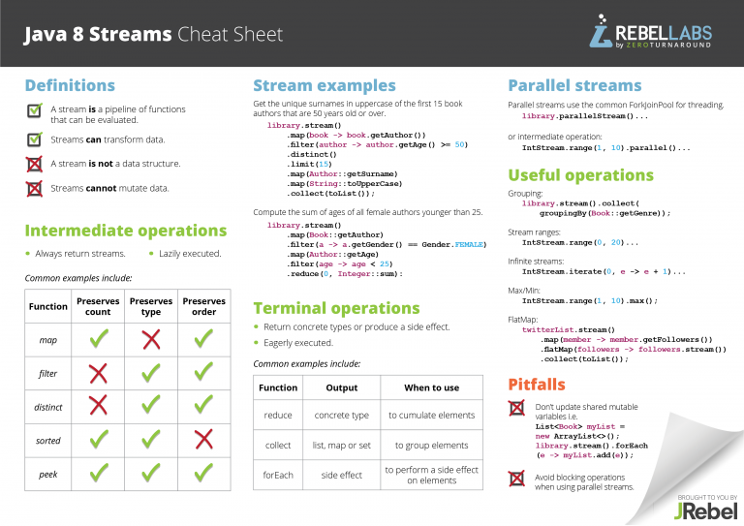

Stream.of :-
We can use Stream.of() to create a stream from similar type of data. For example, we can create Java Stream of integers from a group of int or Integer objects.
Stream<Integer> stream = Stream.of(1,2,3,4);
- We can use Stream.of() with an array of Objects to return the stream. Note that it doesn’t support autoboxing, so we can’t pass primitive type array.
Stream<Integer> stream = Stream.of(new Integer[]{1,2,3,4});
//works fine

Stream<Integer> stream1 = Stream.of(new int[]{1,2,3,4});
//Compile time error, Type mismatch: cannot convert from Stream<int[]> to Stream<Integer>
- We can use Collection stream() to create sequential stream and parallelStream() to create parallel stream.
List<Integer> myList = new ArrayList<>();
for(int i=0; i<100; i++) myList.add(i);

//sequential stream
Stream<Integer> sequentialStream = myList.stream();

//parallel stream
Stream<Integer> parallelStream = myList.parallelStream();
- We can use Stream.generate() and Stream.iterate() methods to create Stream.
Stream<String> stream1 = Stream.generate(() -> {return "abc";});
Stream<String> stream2 = Stream.iterate("abc", (i) -> i);
- Using Arrays.stream() and String.chars() methods.
LongStream is = Arrays.stream(new long[]{1,2,3,4});
IntStream is2 = "abc".chars();

Converting Java Stream to Collection or Array
There are several ways through which we can get a Collection or Array from a java Stream.
- We can use java Stream collect() method to get List, Map or Set from stream.
Stream<Integer> intStream = Stream.of(1,2,3,4);
List<Integer> intList = intStream.collect(Collectors.toList());
System.out.println(intList); //prints [1, 2, 3, 4]

intStream = Stream.of(1,2,3,4); //stream is closed, so we need to create it again
Map<Integer,Integer> intMap = intStream.collect(Collectors.toMap(i -> i, i -> i+10));
System.out.println(intMap); //prints {1=11, 2=12, 3=13, 4=14}
- We can use stream toArray() method to create an array from the stream.
Stream<Integer> intStream = Stream.of(1,2,3,4);
Integer[] intArray = intStream.toArray(Integer[]::new);
System.out.println(Arrays.toString(intArray)); //prints [1, 2, 3, 4]

Java Stream Intermediate Operations
Let’s look into commonly used java Stream intermediate operations example.
- Stream filter() example: We can use filter() method to test stream elements for a condition and generate filtered list.
List<Integer> myList = new ArrayList<>();
for(int i=0; i<100; i++) myList.add(i);
Stream<Integer> sequentialStream = myList.stream();

Stream<Integer> highNums = sequentialStream.filter(p -> p > 90); //filter numbers greater than 90
System.out.print("High Nums greater than 90=");
highNums.forEach(p -> System.out.print(p+" "));
//prints "High Nums greater than 90=91 92 93 94 95 96 97 98 99 "
- Stream map() example: We can use map() to apply functions to an stream. Let’s see how we can use it to apply upper case function to a list of Strings.
Stream<String> names = Stream.of("aBc", "d", "ef");
System.out.println(names.map(s -> {
return s.toUpperCase();
}).collect(Collectors.toList()));
//prints [ABC, D, EF]
- Stream sorted() example: We can use sorted() to sort the stream elements by passing Comparator argument.
Stream<String> names2 = Stream.of("aBc", "d", "ef", "123456");
List<String> reverseSorted = names2.sorted(Comparator.reverseOrder()).collect(Collectors.toList());
System.out.println(reverseSorted); // [ef, d, aBc, 123456]

Stream<String> names3 = Stream.of("aBc", "d", "ef", "123456");
List<String> naturalSorted = names3.sorted().collect(Collectors.toList());
System.out.println(naturalSorted); //[123456, aBc, d, ef]
- Stream flatMap() example: We can use flatMap() to create a stream from the stream of list. Let’s see a simple example to clear this doubt.
Stream<List<String>> namesOriginalList = Stream.of(
Arrays.asList("Pankaj"),
Arrays.asList("David", "Lisa"),
Arrays.asList("Amit"));
//flat the stream from List<String> to String stream
Stream<String> flatStream = namesOriginalList
.flatMap(strList -> strList.stream());

flatStream.forEach(System.out::println);

Java Stream Terminal Operations
Let’s look at some of the java stream terminal operations example.
- Stream reduce() example: We can use reduce() to perform a reduction on the elements of the stream, using an associative accumulation function, and return an Optional. Let’s see how we can use it multiply the integers in a stream.
Stream<Integer> numbers = Stream.of(1,2,3,4,5);

Optional<Integer> intOptional = numbers.reduce((i,j) -> {return i*j;});
if(intOptional.isPresent()) System.out.println("Multiplication = "+intOptional.get()); //120
- Stream count() example: We can use this terminal operation to count the number of items in the stream.
Stream<Integer> numbers1 = Stream.of(1,2,3,4,5);

System.out.println("Number of elements in stream="+numbers1.count()); //5
- Stream forEach() example: This can be used for iterating over the stream. We can use this in place of iterator. Let’s see how to use it for printing all the elements of the stream.
Stream<Integer> numbers2 = Stream.of(1,2,3,4,5);
numbers2.forEach(i -> System.out.print(i+",")); //1,2,3,4,5,
- Stream match() examples: Let’s see some of the examples for matching methods in Stream API.
Stream<Integer> numbers3 = Stream.of(1,2,3,4,5);
System.out.println("Stream contains 4? "+numbers3.anyMatch(i -> i==4));
//Stream contains 4? true

Stream<Integer> numbers4 = Stream.of(1,2,3,4,5);
System.out.println("Stream contains all elements less than 10? "+numbers4.allMatch(i -> i<10));
//Stream contains all elements less than 10? true

Stream<Integer> numbers5 = Stream.of(1,2,3,4,5);
System.out.println("Stream doesn't contain 10? "+numbers5.noneMatch(i -> i==10));
//Stream doesn't contain 10? true
- Stream findFirst() example: This is a short circuiting terminal operation, let’s see how we can use it to find the first string from a stream starting with D.
Stream<String> names4 = Stream.of("Pankaj","Amit","David", "Lisa");
Optional<String> firstNameWithD = names4.filter(i -> i.startsWith("D")).findFirst();
if(firstNameWithD.isPresent()){
System.out.println("First Name starting with D="+firstNameWithD.get()); //David
}

